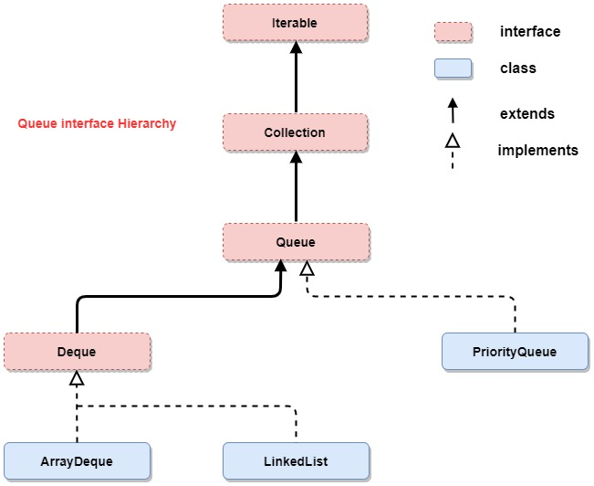

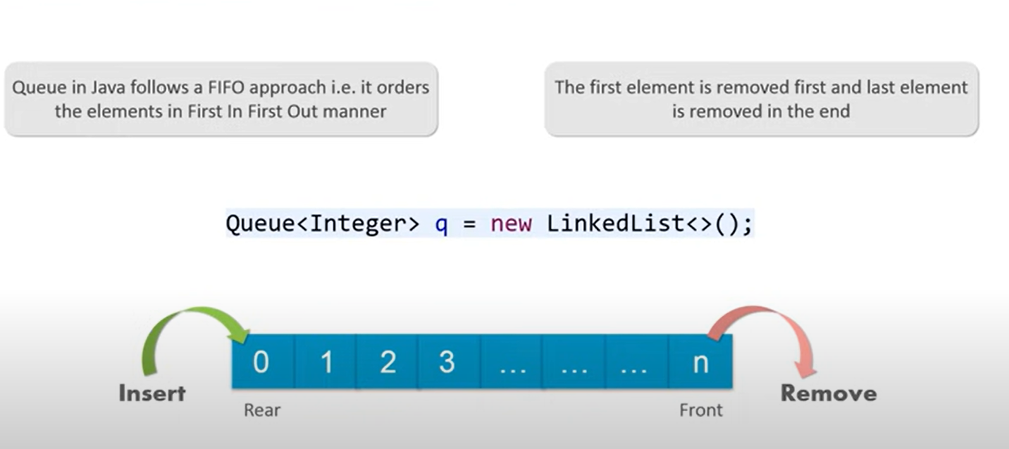

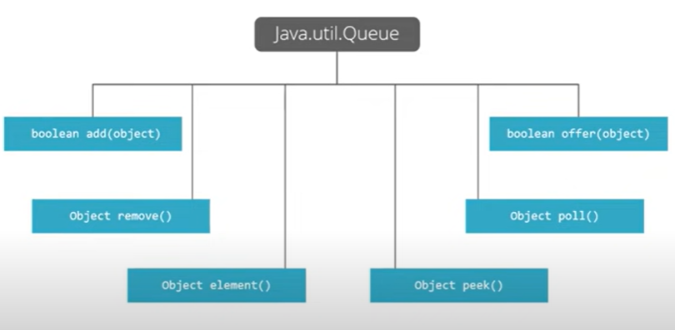

|  |  |  |
| --- | --- | --- |
| Method | Throws exception | Return Boolean type |
| Insert | Add(e) | Offer ( e ) |
| Remove( take data and delete ) | Remove() | Poll() |
| Examine( take data but not delete) | Element() | Peek() |

Dequeue: 2 đầu vào và 2 đầu ra

|  |  |  |  |  |
| --- | --- | --- | --- | --- |
|  | First element | Last element | First element | Last element |
| Type of method | Throws exception | Throws exception | Special value | Special Value |
| Insert | addFirst() | addLast() | offerFirst() | offerLast() |
| Remove | removeFirst() | removeLast() | pollFirst() | pollLast() |
| Examine | getFirst() | getLast() | peekFirst() | peekLast() |

